**Appendix 8**. Model results for species-area relationships in cities, species-area relationships in random polygon patches, and for the comparison between the two.

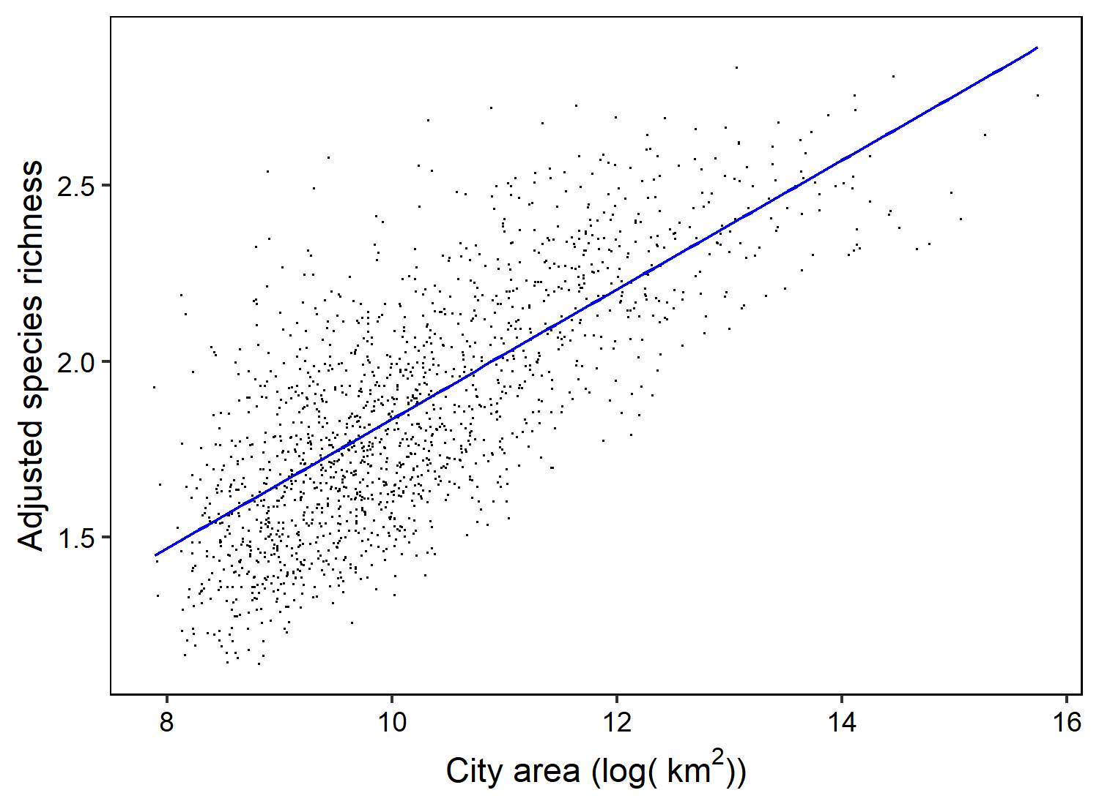

**Figure A1**. Adjusted species richness after accounting for the total number of eBird lists in a city using weights, and a smoothed 2-dimensional spline for latitude and longitude, to account for gradients in species richness, as a result of a Generalized Additive Model. The plot was made using the mgcViz package in R.

**Table A1**. Model results from a Generalized Additive Model for the species-area relationship for cities (i.e., area).

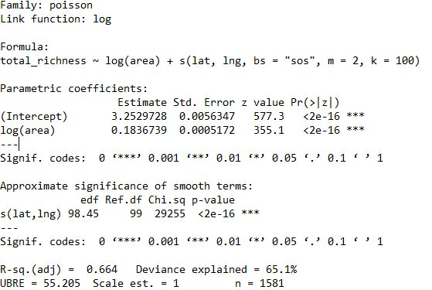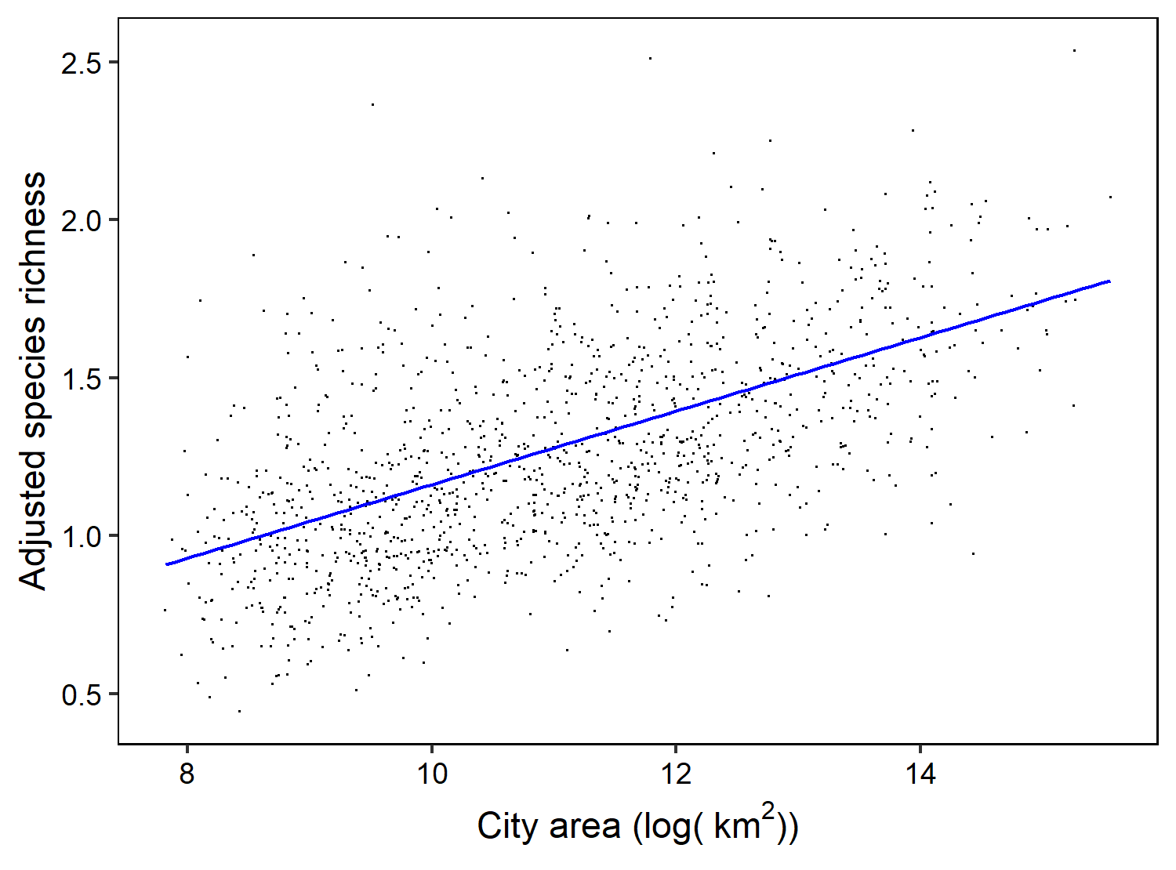

**Figure A2**. Adjusted species richness after accounting for the total number of eBird lists in a random polygon patch using weights, and a smoothed 2-dimensional spline for latitude and longitude, to account for gradients in species richness, as a result of a Generalized Additive Model. The plot was made using the mgcViz package in R.

**Table A2**. Model results from a Generalized Additive Model for the species-area relationship among random polygon patches.

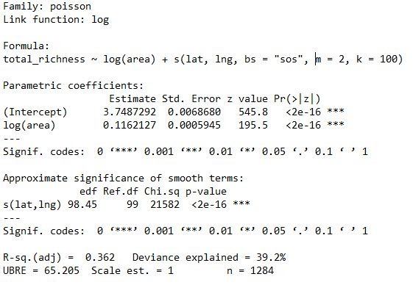

**Table A3**. Model results from a Generalized Additive Model which assessed the interaction between log-transformed patch area and ‘analysis’, explicitly testing the difference in slope between cities and random polygon patches.

